**Tic tac toe의 test case**

1. Test case(세로줄 심볼 3개 완성)

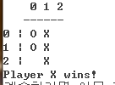입력:

|  |  |
| --- | --- |
| 입력 프롬트 | 입력값 |
| Player X(행 열):  Player O(행 열):  Player X(행 열):  Player O(행 열):  Player X(행 열): | 1 1  0 0  0 1  1 0  2 1 |

결과:

Player X wins!

1. 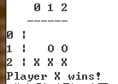Test case(가로줄 심볼 3개 완성)  
   입력:

|  |  |
| --- | --- |
| 입력 프롬트 | 입력값 |
| Player X(행 열):  Player O(행 열):  Player X(행 열):  Player O(행 열):  Player X(행 열): | 2 2  1 1  2 1  1 2  2 0 |

결과:  
Player X wins!

1. Test case(대각선 심볼 3개 완성)

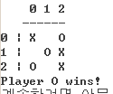입력:

|  |  |
| --- | --- |
| 입력 프롬트 | 입력값 |
| Player X(행 열):  Player O(행 열):  Player X(행 열):  Player O(행 열):  Player X(행 열):  Player O(행 열): | 1 2  1 1  2 2  0 2  0 0  2 0 |

결과:

Player O wins!

1. Test case(백 대각선 심볼 3개 완성)

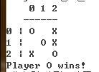입력:

|  |  |
| --- | --- |
| 입력 프롬트 | 입력값 |
| Player X(행 열):  Player O(행 열):  Player X(행 열):  Player O(행 열):  Player X(행 열):  Player O(행 열): | 1 2  1 1  0 2  0 0  2 0  2 2 |

결과:  
Player 0 wins!

1. Test case(그림판이 완성되면서 승이 확정되는 경우)

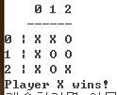입력:

|  |  |
| --- | --- |
| 입력 프롬트 | 입력값 |
| Player X(행 열):  Player O(행 열):  Player X(행 열):  Player O(행 열):  Player X(행 열):  Player O(행 열):  Player X(행 열):  Player O(행 열):  Player X(행 열): | 0 0  1 1  0 1  0 2  1 0  1 2  2 2  2 1  2 0 |

결과:

Player X wins!

1. Test case(그림판이 완성되었지만 승패가 안남)

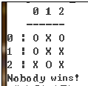입력:

|  |  |
| --- | --- |
| 입력 프롬트 | 입력값 |
| Player X(행 열):  Player O(행 열):  Player X(행 열):  Player O(행 열):  Player X(행 열):  Player O(행 열):  Player X(행 열):  Player O(행 열):  Player X(행 열): | 1 1  0 0  0 1  2 1  2 0  0 2  1 2  1 0  2 2 |

결과:  
Nobody wins!

1. 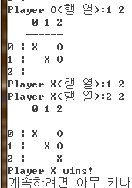Test case(동일한 좌판 입력)

|  |  |
| --- | --- |
| 입력 프롬트 | 입력값 |
| Player X(행 열):  Player O(행 열):  Player X(행 열):  Player O(행 열):  Player X(행 열):  Player X(행 열): | 1 1  0 2  0 0  1 2  1 2  2 2 |

결과:

Player X wins!